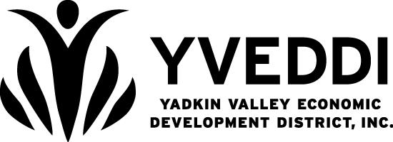
YVEDDI Pledge Campaign
Workplace Campaign 2021-2022
My Information
Name
Home Address
Email Address |  |  |  | Phone
My Pledge |  | Enter your donation amount $
Direct my contribution to the following: (Select Option Below)
*Yadkin County United Fund  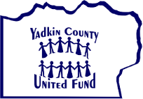 |  | Yadkin Valley United Fund  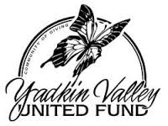 | 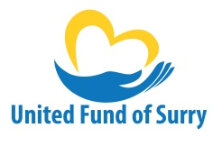  *United Fund of Surry |  |  | United Fund of Stokes  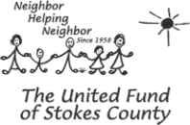
Designate my gift to a specific agency: (optional) See list on back
*A $50 minimum donation is required to designate a specific agency.
I am giving a one-time tax deductible gift of $ Cash Check (Check Number: )
Make check payable to YVEDDI (specify United Fund name in the memo) and return with form
Payroll Deduction: I am doing a payroll deduction through YVEDDI

$ x 26 (bi-weekly) = $
$ paycheck # of pay periods Total payroll deduction

Deductions begin January 2022 and continue through December 2022
I want my gift to remain anonymous
Perks at Work | Level of Contribution |  |  | Perks
 | $220 per year club ($8.47 per pay period payroll deduction) |  |  | Voucher for 24 hours Admin Leave
 | $120 per year club ($4.62 per pay period payroll deduction) |  |  | Voucher for 12 hours Admin Leave
 | $100 one-time gift |  |  | Voucher for 8 hours Admin Leave
 | $50 one-time gift |  |  | Voucher for 4 hours Admin Leave
 | $25 one-time gift |  |  | Voucher for 2 hours Admin Leave
Please complete the attached United Fund form and turn in to your supervisor for submission to the YVEDDI District Office by October 31st, 2021.

Administrative Leave must be scheduled and prior approved by the program director. Leave will be awarded when contribution is verified per copy of check or contribution form submitted to the Executive Director.
Signature Date

Yadkin County United Fund Agencies | Yadkin Valley United Fund Agencies
American Red Cross  Boonville Community Public Library  Boy Scouts of America  Cancer Services  Children’s Center of Yadkin  East Bend Public Library  Grace Clinic  Jonesville Public Library  Mountain Valley Hospice – Yadkin Co.  Share A Home  Smart Start of Yadkin County Dolly Parton Imagination Library  The Ark Homeless Shelter  The Salvation Army  Tri-County Christian Crisis Ministry  Yadkin Christian Ministries – Medical Assistance  Yadkin County 4-H Clubs  Yadkin County Public Library  Yadkin County Rescue Squad  Yadkin Family YMCA  Yadkin Special Olympics  YVEDDI Domestic Violence (Yadkin County)  YVEDDI Senior Services  For FAQ or more information visit www.yadkincountyunitedfund.org | American Red Cross / Surry County Chapter  Boy Scouts of America-Old Hickory Council  Cancer Services of Elkin  CareNet Counseling of Wilkes/Elkin  Children’s Center of Surry  D.A.R.E  ECHO Ministries-The ARK  Elkin Lions Club  Elkin Rescue Squad  Feed The Elderly  Foothills Art Council  Girl Scout Hut Fund  Grace Clinic Yadkin Valley  Jonesville Public Library  Mountain Park Rescue Squad  Mountain Valley Hospice  SAFE, Inc.  SHAHC (Surry Homeless and Affordable Housing Coalition)  Salvation Army Surry County  Surry Friends of Youth  Surry Homeless and Affordable Housing Coalition  Tri-County Christian Ministry, Inc.  Triple C Scholarships  Wilkes Developmental Day School  Watershed NOW, Inc.  YVEDDI Surry Domestic Violence & Sexual Assault  YVEDDI Yadkin Valley Senior Services / Community Center  For FAQ or more information visit www.yadkincountyunitedfund.org
United Fund of Surry Agencies | United Fund of Stokes Agencies
American Red Cross  Ararat Rescue Squad  Armfield Civic Center: Camp Pilot Mountain  Blue House Teaching Studio  Blue Ridge Volunteer Rescue Squad  Boy Scouts: Old Hickory Council  Children’s Center Of Surry  Dobson Rescue Squad  Girl Scouts: Peaks To Piedmont Council  Mountain Valley Hospice And Palliative Care  Mount Airy Rescue Squad  Pilot Mountain Rescue Squad  Reeves Community Center Foundation  Surry Arts Council: Special Needs Program  Surry Friends Of Youth  Surry Homeless And Affordable Housing Coalition  Surry SCAN (Stop Child Abuse Now)  Surry Medical Ministries  The Salvation Army  The Shepherd’s House  Webb Southern Carroll Community Club  YOKEFELLOW Cooperative Ministry  YVEDDI Surry Domestic Violence And Sexual Assault  YVEDDI Senior Services  For FAQ or more information visit www.unitedfundofsurry.org | American Red Cross  Bowman Gray Child Guidance  Boy Scouts, Old Hickory Council  Cancer Services  Group Homes of Forsyth County  Hospice & Palliative Care Center  Mountain Valley Hospice & Palliative Care Joan & Howard Woltz Hospice Home  Stokes Advocacy Council to Seniors  Stokes County 4-H  Stokes County Public Library Summer Reading Program  Stokes County Special Olympics  Stokes Family YMCA  Stokes Friends of Youth  Stokes SCAN  The Salvation Army  YVEDDI Stokes Domestic Violence And Sexual Assault  For FAQ or more information visit www.unitedfundofstokes.org

