**YVEDDI ELKIN CIRCULATOR**

**Wal-Mart**

**Goody's**

**Food Lion**

**Elkin Center**

LYLES

**Turner Ct Apts**

TURNER

NORTH

**Elkin Municipal Parking Lot**

BLANKET

YVEDDI Bus Timetable

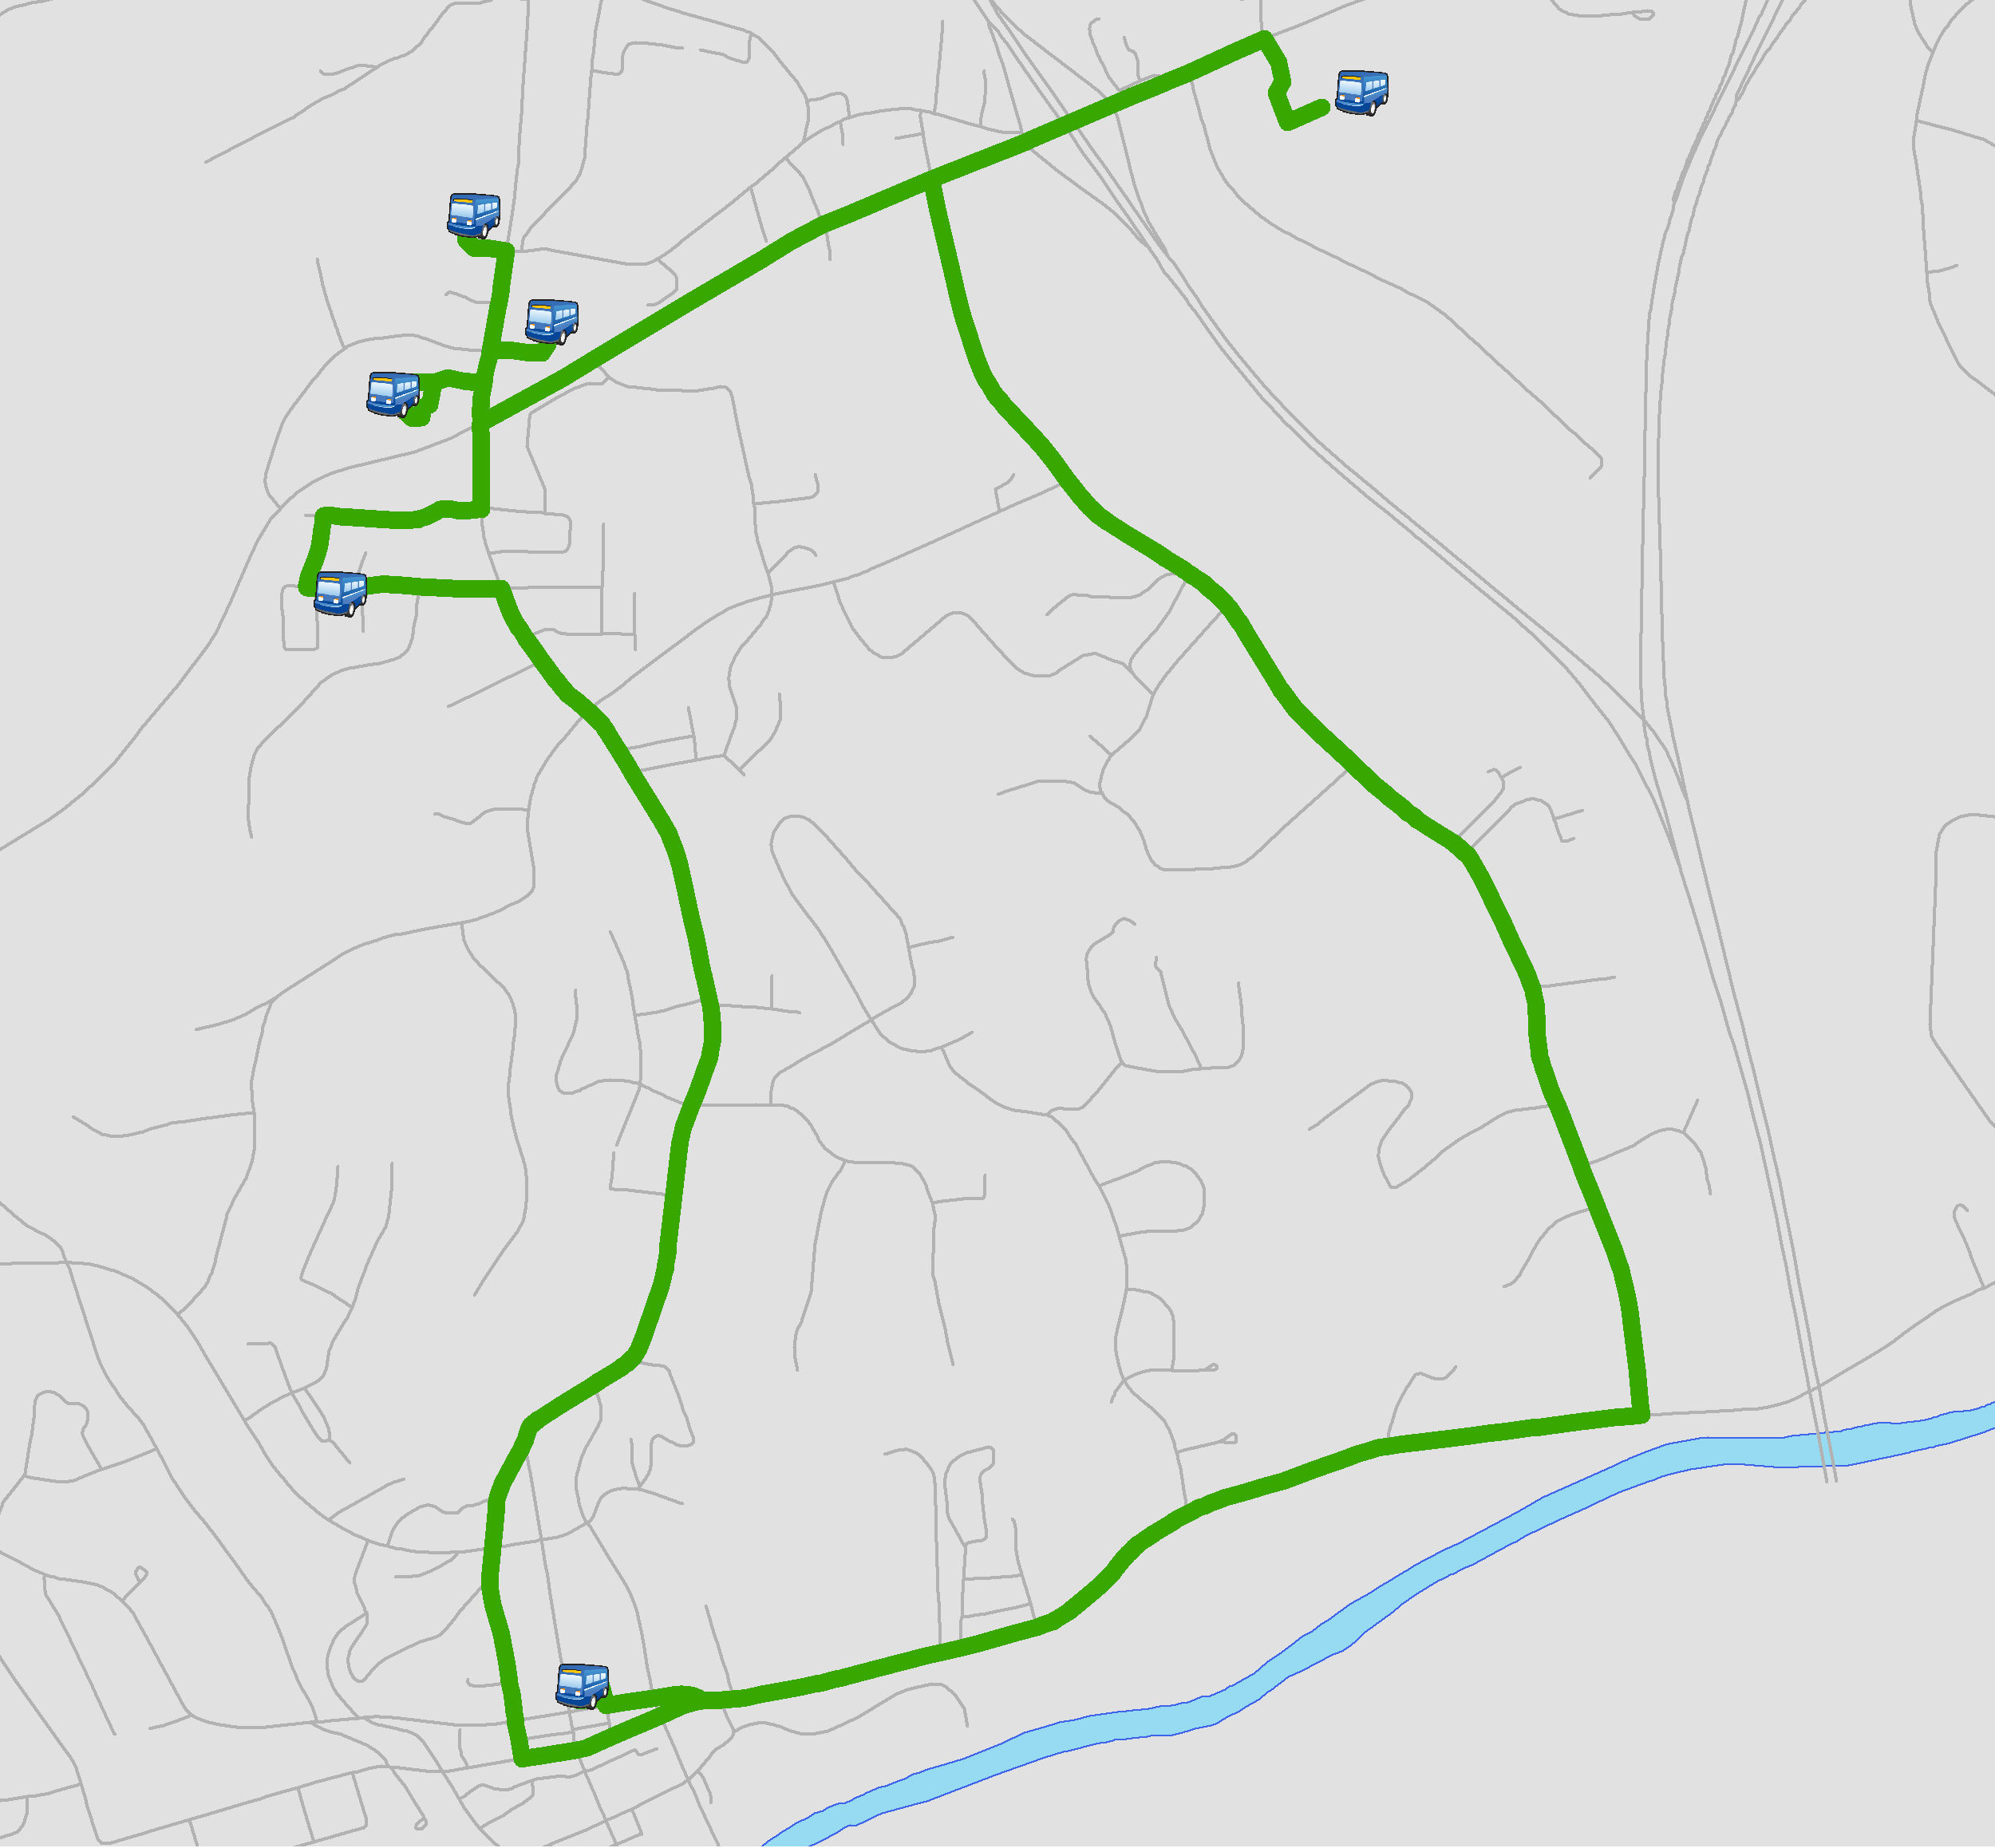

Monday to Friday. 7:00 AM to 6:00 PM. Must call YVEDDI Call Center at 336-679-2071 to schedule home pick-up.

**AM RUN**

YVEDDI Bus Timetable

Monday to Friday. 7:00 AM to 6:00 PM

STOP # Location Time Schedule

1 Elkin Municipal Parking Lot 7:15 8:15 9:15 10:15 11:15

2 Wal-Mart 7:30 8:30 9:30 10:30 11:30

3 Food Lion 7:45 8:45 9:45 10:45 11:45

4 Goody's 7:50 8:50 9:50 10:50 11:50

5 Elkin Center (SCC) 7:55 8:55 9:55 10:55 11:55

6 Turner Ct Apts 8:00 9:00 10:00 11:00 12:00

**PM RUN**

STOP # Location Time Schedule

1 Elkin Municipal Parking Lot 12:15 1:15 2:15 3:15 4:15 5:15

2 Wal-Mart 12:30 1:30 2:30 3:30 4:30 5:30

3 Food Lion 12:45 1:45 2:45 3:45 4:45 5:45

4 Goody's 12:50 1:50 2:50 3:50 4:50 5:50

5 Elkin Center (SCC) 12:55 1:55 2:55 3:55 4:55 5:55

6 Turner Ct Apts 1:00 2:00 3:00 4:00 5:00 6:00

A fare of $1 per trip will be charged to ride the Elkin Circulator. An additional $2.00 is charged to ride the Surry-Yadkin Connector. Correct change is required and no receipts are written by the driver. A prepaid fare can be arranged through the transportation office with a receipt written.

Medicaid passengers must be pre-approved and pre-scheduled to ride.